Cacti-ReportIt v2.0

The Cacti Reporting Plugin

License
Copyright (c) 2009-2024 The Cacti Group and Andreas Braun
Permission is granted to copy, distribute and/or modify this document under the terms of the GNU Free Documentation License, Version 1.2 or any later version published by the Free Software Foundation; with no Invariant Sections, no Front-Cover Texts, and no Back-Cover Texts.

Preface
Dear Cacti Community, almost 20 years ago I wrote my thesis at the University of Applied Sciences, Cologne, and I never thought that this project would become one of my hobbies. This exercise concentrates on the steps, which are necessary to set up a report by solving a typical problem:
“I have to report each month over utilized network links to our customer. My threshold value is 80%”. How can I solve that issue using ReportIt? From my point of view, it’s a good way to get an overview about ReportIt even though not all available flags and configuration parameters will be discussed within this script.
Thanks to all those who have spent a lot of time to improve ReportIt! This exercise is long overdue, so I braced myself up to fulfill your wish for help. I’ll extend it from time to time with some new topics.
Best regards
-Andreas-

Purpose
ReportIt is designed as a plugin for Cacti, the RRDtool-based graphing solution. It provides the fast creation of customized reports with thousands of data items, self-defined metrics and variables - particularly with regard to individual working days and working hours. It then can present these reports in both tabular and in graphic form through the Cacti user interface. The ReportIt plugin also allows tabular Reports to be sent to a select list of users or Cacti Notification Lists.

Features
The ReportIt plugin is like many other Cacti plugins. It comes with a simple to install interface and then once installed provides the following features:
- Definition of individual Report Templates through the creation of Template Metrics and Variables using a suite of functions that pull data from RRDtool’s Round Robin Archives.
- Definition of Report configurations based upon the pre-defined Report Templates and with the ability to define an entirely separate set of data.
- The ability to individually configure working days, working times, and time zones as well as sub-headings per data item.
- Scheduled reporting with sliding time frames for each Report.
- Rounding with binary or decimal SI-Prefixes for Report output.
- Exporting of Report data to CSV, MS Excel compatible XML as well as raw XML
- Different ways of connecting RRDtool including use of the RRDtool Proxy, or the PHP RRDtool module.
- Handles the complexities of Day Light Saving Time (DST) switches inherit in many TSDB databases
- Supports the Auto dispatch of scheduled reports via email.
- Support the creation of Top 10 charts
- Includes the ability to archive Report history

Installation
The current version of ReportIt was designed for Cacti 1.x+. The current minimum version is Cacti 1.2.27. To install the ReportIt plugin is fairly simple as follows:
- Install Cacti 1.2.27++ on your system
- Confirm that basic data collection is working and your Cacti log is free from errors.
- Download either the develop version of ReportIt or the most recently tagged version from GitHub
- Copy the plugin files to <base_path>/plugins/reportit
- Recursively change permission on the plugin files to be owned by your web server account, normally either the apache or www-data users.
- From the Cacti Console, go to Configuration > Plugins and find the ReportIt plugin.
- Press the Install and then Enable buttons.
- Go to Console > Configuration > Settings > ReportIt and review ReportIt Settings.
That’s it. That is all that is required to install and enable the ReportIt plugin. Note that the default administrative user will have access to the ReportIt interface, but once you have familiarized yourself with the interface, you should selectively enable access for other users or groups.

Users and Groups
The User and User Group rights can be defined by the following realm permissions under Cacti's Users and User Group interfaces.
ReportIt – View Reports
ReportIt – Create Reports
ReportIt – Manage Reports
The roles above of Users permission can be set either at the User or User Group level. We recommend that assignments be applied at the User Group level if possible. You can see the default user permissions for RepotIt below.
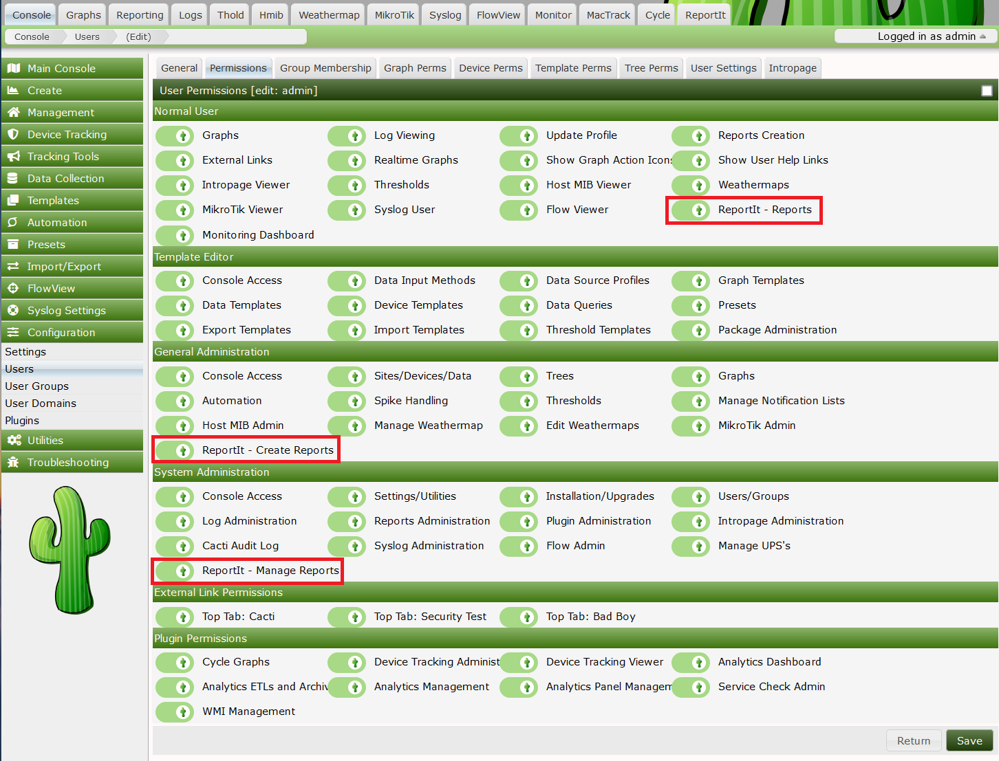

Report Templates

What is a report template?
A Report Template is the base plate for creating reports. It contains the definition of metrics, which should be displayed in every derived report. Furthermore, it's allowed to use variables within the definition of a metric, which have been declared before.
This allows us to create a lot of different templates for several scenarios like the analysis of "CPU Utilization", "Interface Traffic" and so on. Honestly, creating new report templates is not so easy, because it is indispensable to have a fundamental knowledge about RRDtool and your environment as well. That's the point where a lot of Cacti users begin to struggle and the reason why it is important to concentrate on the basics first. For this very reason it is advisable that a simple user should not have access to that section.

Working with Metrics

Working with Variables

Report Configurations

What is a Report Configuration?
A report configuration combines a report template with the right data items (e.g. network interfaces), which should be part of the report. Therefore, a power user has the permission to select a template, to define the reporting period, to set up variables (defined within the report template) and to add several data items besides changing a bunch of additional settings.
ReportIt supports different types of users and makes a distinction between different ownerships. The creator of a report configuration becomes automatically the owner of it and is entitled to make it public or not. Additionally, it’s possible to set up office hours, time zones, email recipients and so on.

Creating your First Report Template!
After we have ensured the correctness of our permissions we will find new entries in Cacti’s console. At first, we take a look at the section called “Templates” and we select “Report Templates”. Now we have to fill up the empty table with our first report template. A simple click on “Add” in the right upper corner opens the dialogue box. As you can see below ReportIt offers us a lot of data templates, which are all in use. We choose data template "Interface Traffic" from the drop-down list as shown below.
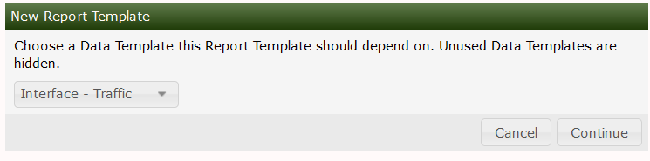
With a short click on “next” we arrive an individual configuration page where we can name our new template. Until we have not finished the whole template configuration including a minimum of one new metrics, the template will be automatically locked. So, it will be unusable for power users during that time.
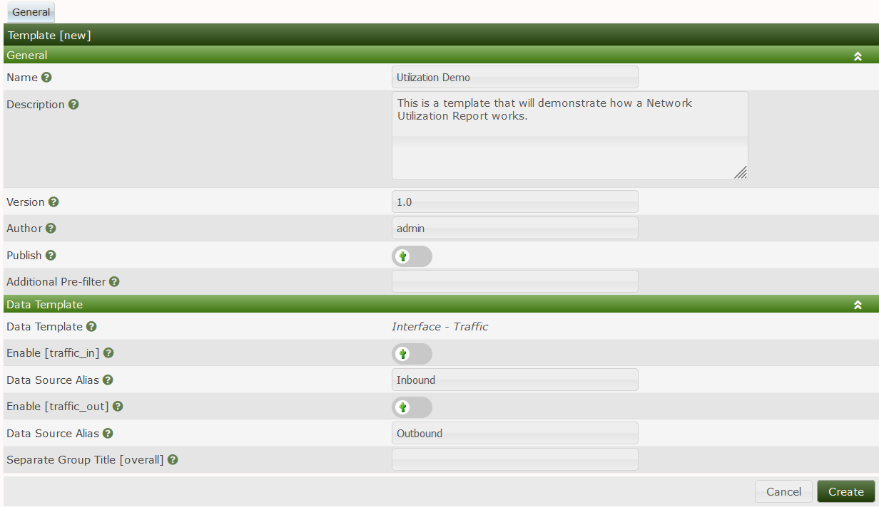
As we know RRDtool supports several functions to consolidate measured values. Excluding ReportIt 0.7.0 it becomes necessary that we choose which CDPs (Consolidated Data Points) should be readout during the calculation process. (With the upcoming release this selection will be shifted to the metric configuration to increase the flexibility). Under “Data Template” we see the data template chosen within the last step and the included data source items. The names of these items will be used automatically within the report. In certain circumstances it will make sense we define an alias’s instead of using the original name.
After fulfilling the form as shown above and a click on “create”, two new (blue) links will appear in the right upper corner. We want to create directly a flexible template instead of using a static threshold value of 80%. So, we select "Create a new variable" to create our first variable.
This variable will define the threshold value selectable for all power users (and super users as well) within their report configurations. Therefore, we want to offer them a drop-down list that shows values from 50 to 100 % with a step size of 1. The description will explain power users the sense of the variable.
With the successful creation of that variable, we can see the list with all defined variables for our report template. Okay, we have only a single one till now, but we can take a look at the internal (unique) name given for it (e.g. "c1v"). We will need this information later, but we do not have to write it down.
By using the yellow link "Utilization demo" shown in the table header we will get back to the configuration of our template. Let’s create our first metric that will show us the bandwidth of every interface. Therefore, we select the second link called “Create a new metric”.
A metric will be calculated automatically for every data source defined in Cacti’s data template. In this exercise it will return two results per data item: one for the inbound and one for the outbound traffic. So, it becomes important to find a good name and a better unique abbreviation, because that abbreviation will allow us to address these interim results within the calculation process of subsequent metrics.

Hiding Metrics
ReportIt also provides the possibility of creating auxiliary calculations, which can be hidden within the report through the deactivation of the “visible” flag. If we need only a single result instead of one for every data source then we have to select “separate”. The calculation formula describes in a “pseudo” - mathematical way what ReportIt has to do with the measured values readout of the RRD file. Therefore, we are allowed to combine functions, constants and variables with operators. Don’t be reluctant to improve the readability of your formula by using round brackets! And moving the pointer over the different functions will display us more information about it.
Clicking on these items will automatically add them to our calculation formula. After we fulfilled all fields and clicked on “create” we will see a list of defined metrics for your report template. The “Add” link allows proceeding with another new metric. The second metric should display the average load of every data source, which will be “traffic _in” (alias Inbound) and “traffic_out” (alias Outbound) in our case: "f_avg*8" means that ReportIt has to calculate the average of all valid measured values per data source during a reporting period. As you know routers use to count "Bytes/s", instead of "Bits/s". So, we have to multiply it with 8 being in line with our traffic graphs.
Here comes the third metric that should display the "Utilization Ratio. Take a look at the bottom of the screenshot. Did you recognize the variable we have defined at the beginning? We will use it soon, but we have to concentrate on the interim results first.
This plugin permits us to bring back into use, what have been calculated before: Using the abbreviation of another metric within the calculation formula instructs ReportIt to fill in automatically the corresponding result per data source. If the calculation of that older metric will only return a single result (We remember the separate flag!), then this one will be filled in. Furthermore, it can be very helpful to address directly these results returned per data source. For example we can calculate the sum of the averaged inbound and outbound traffic with a simple “AVG:traffic_in+AVG:traffic_out”.
Last but not least we should get back to the sense of that metric. This metric will return separately the averaged utilization ratio of inbound and outbound, which we have during the reporting period.
Okay, let's create our last and most important metric "Percentage over threshold" or “POT” for short. So, what does this mean? It will reveal how many percent of our business time was the threshold for inbound and outbound exceeded during the reporting period. That sounds complicated.
ReportIt supports working hours within a report configuration. The default is always set to 24 hours, but e.g. we use to work for 8 hours. So, if we created a report over the last month with a “POT” of 60%, then we would know that 60% of our working hours the interface utilization was over the threshold we’ve defined (e.g. 90% of max bandwidth).
With 8 working hours, the guys of our district office could not work properly for around 4,8 hours per business day. In that case we should ask the upper management for money to increase the bandwidth of our WAN link or we have to find the guy who tries to back up the Internet.
As you see above there's our variable used within the calculation formula and with a click on “create” we will get back to the overview of our metrics. Click once again on the yellow link and disable the checkbox "locked" within the template configuration.
Cool! Now we finished the most difficult part! Come on! Let's set up a new report configuration:
At first, we select “Report Configuration” under Cacti’s Console to get an overview of all defined report configuration. The table is empty so we click on “Add” to fill it up now. Within the next dialogue box, we are requested to select the report template we would like to use. We choose the report template "Utilization demo" from the drop-down list and go on with “next”.
After we typed in a name, we have to decide if our report should be public or restricted. The reporting period can be divided into two different types: Using a sliding time frame means that ReportIt automatically calculates the start and the end date in relation to the predefined time frame selected by us. This is very useful if you want to schedule the report. The second type allows us to define a static time frame.
The threshold variable enters the stage at the end and she’s pre-configured to 80% as requested.
After saving our settings for the first time the other tabs will be activated automatically. Now we choose the second tab called "Data Item Presets" to define presets, which will be used to pre-configure automatically new data items (here we've network interfaces) for this report.
Maybe we are not interested in the data traffic over a weekend, because a district office will be opened only on weekdays. If there are no backup jobs running at night it might make sense to reduce our working time. Using the whole day instead will distort the results in that case, because the threshold value cannot be exceeded at night under these circumstances. We should keep this in mind!
Additional information of a data item can be display within the subhead. Now we have to add some data items: With a click on "Add data items" in the right upper corner we will get an overview of the network interfaces. All of them are matching the data template used within our report template. Having all interesting interfaces added we can get a list of all selected data items with a short click on “cancel”. To edit the working days and working time individually we can select the name of the interface.
We created a report configuration and added some pre-configured data items. Let's go! We are keen on seeing some results! So, we change to section “Report Configurations” once again, where we select our report configuration and choose “Run Report” from the drop-down list. Go!
Perfect! ReportIt has nothing to grumble about and we go on with a click on "view". Here we have our report:
We move the mouse over the abbreviations of the metrics to get a tool tip with their description. Very interesting! Can we explain why POT stays at 100% in the second row? Take a look at the bandwidth. There's no “ifspeed” parameter available and the maximum value is configured to zero within Cacti.
Okay, we configured a report, we have seen results, but we do not want to run it manually (and old reports should be saved in an archive automatically). For this purpose, we can activate a feature called “Auto Archiving” within the global configuration of that Plugin. Therefore, we go to Cacti’s global settings and select the tab called “Reports”.
After that we edit our report configuration and activate “Scheduled Reporting” within the admin tab. Frequency has to be set to “monthly”. Under “Auto generated Archive” we use the possibility to define the maximum size of our report archive. Set to “24” means that ReportIt has to save a maximum of 24 report instances before the oldest one will be overwritten automatically after two years.

Scheduling Reports
Cacti provides a basic poller based scheduler that will run your scheduled reports each day at midnight. If they are Daily Reports, they will be run each day at midnight. If they are Weekly Report’s they will run on the first day of each week at midnight. If they are monthly, they will run on the fist day of the month at midnight. The same rules apply for both Quarterly and Yearly reports.
The reports run fairly quickly, but if you are concerned about them running too long, you can set a maximum runtime from the user interface.
You can manually run a report at any time through either the Cacti ReportIt interface, or through the command line. If you wish to run a specific report through the command line, you can simply run the following command as either the root or the apache account.
php <base_path>/plugins/reportit/poller_reportit.php --report-id=N
You can get help for the CLI script using the--help command line option.

